**ASSIGNMENT**

**Step-1:** Enter any name for server

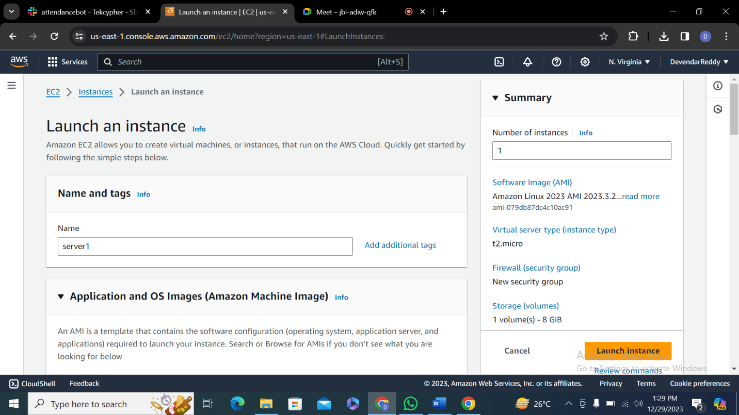

**Step-2:** Select amazon linux as it is most used os

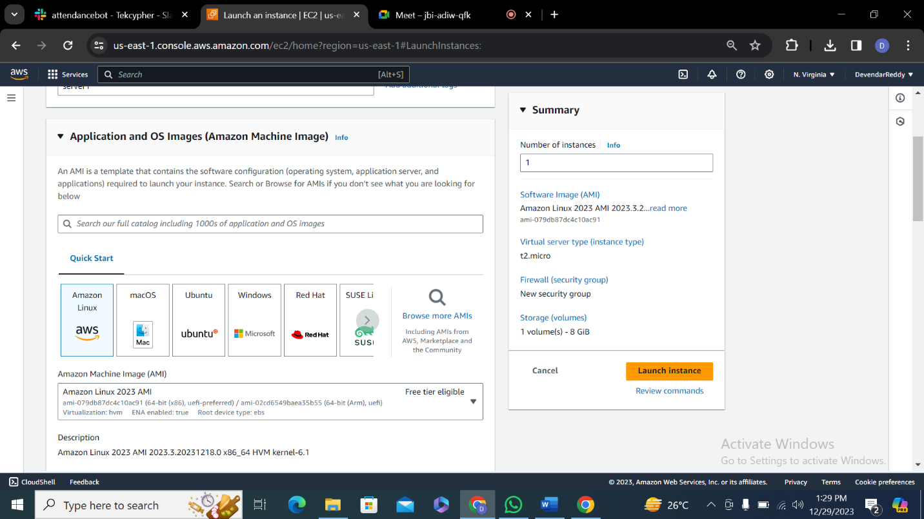

**Step-3** Select t2 micro which is free tier.

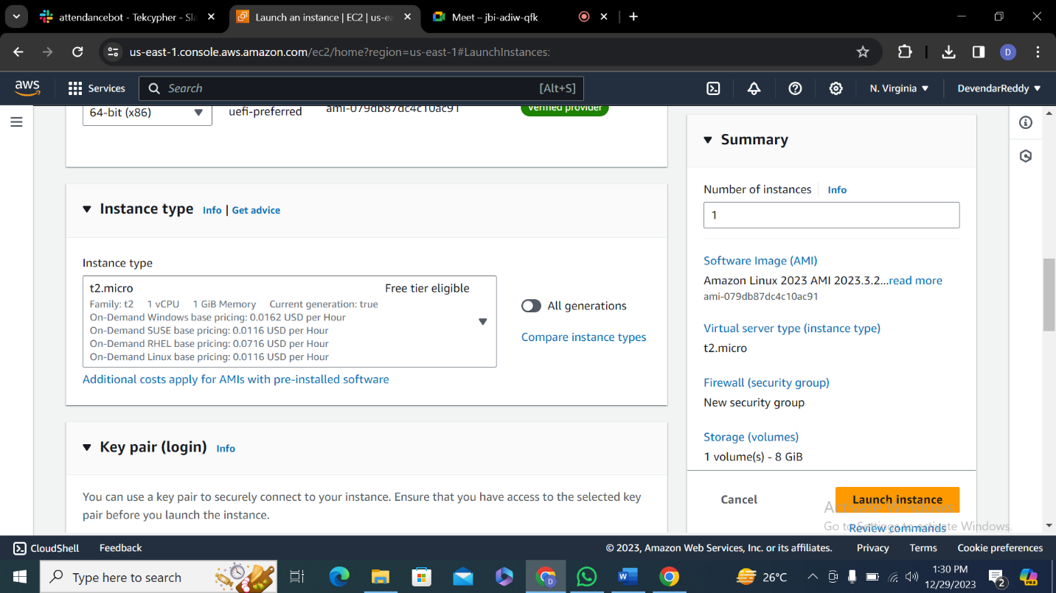

**Step-4: C**reate a key pair to securely connect to your instance.

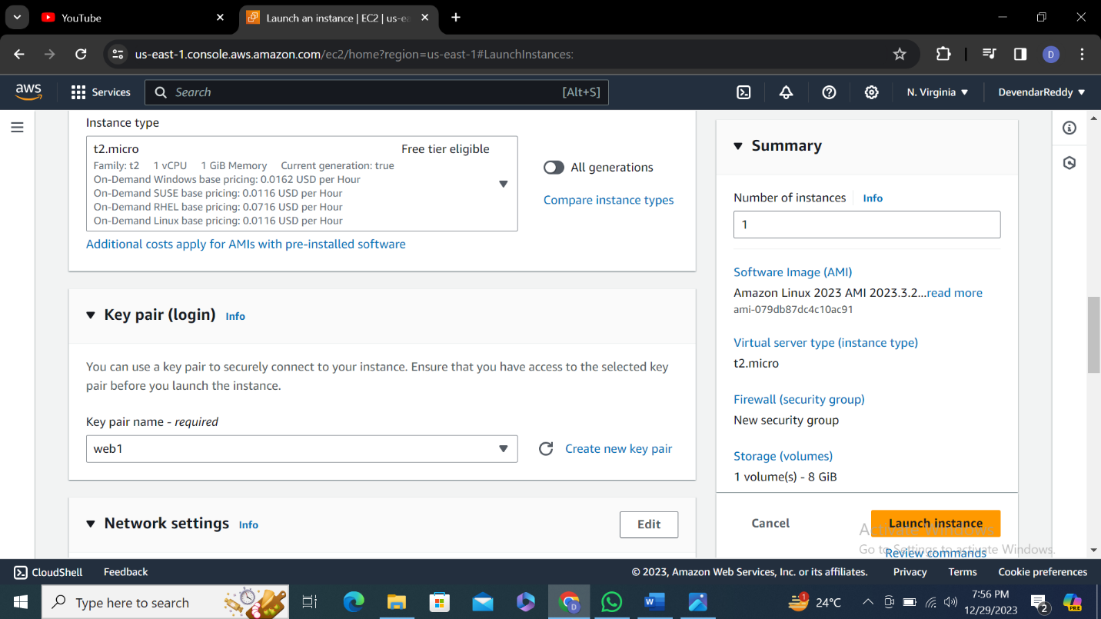

**Step-5:** Make sure network setting and configure storage are by default and click on launch instance.

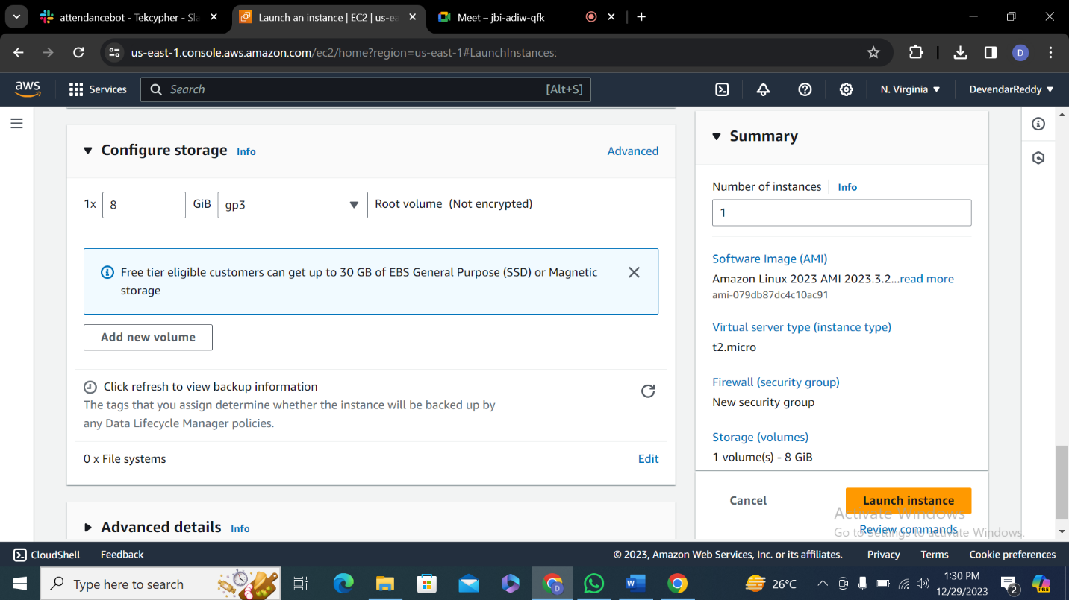

**Step-6:** Make sure status check is 2/2 check and click on connect

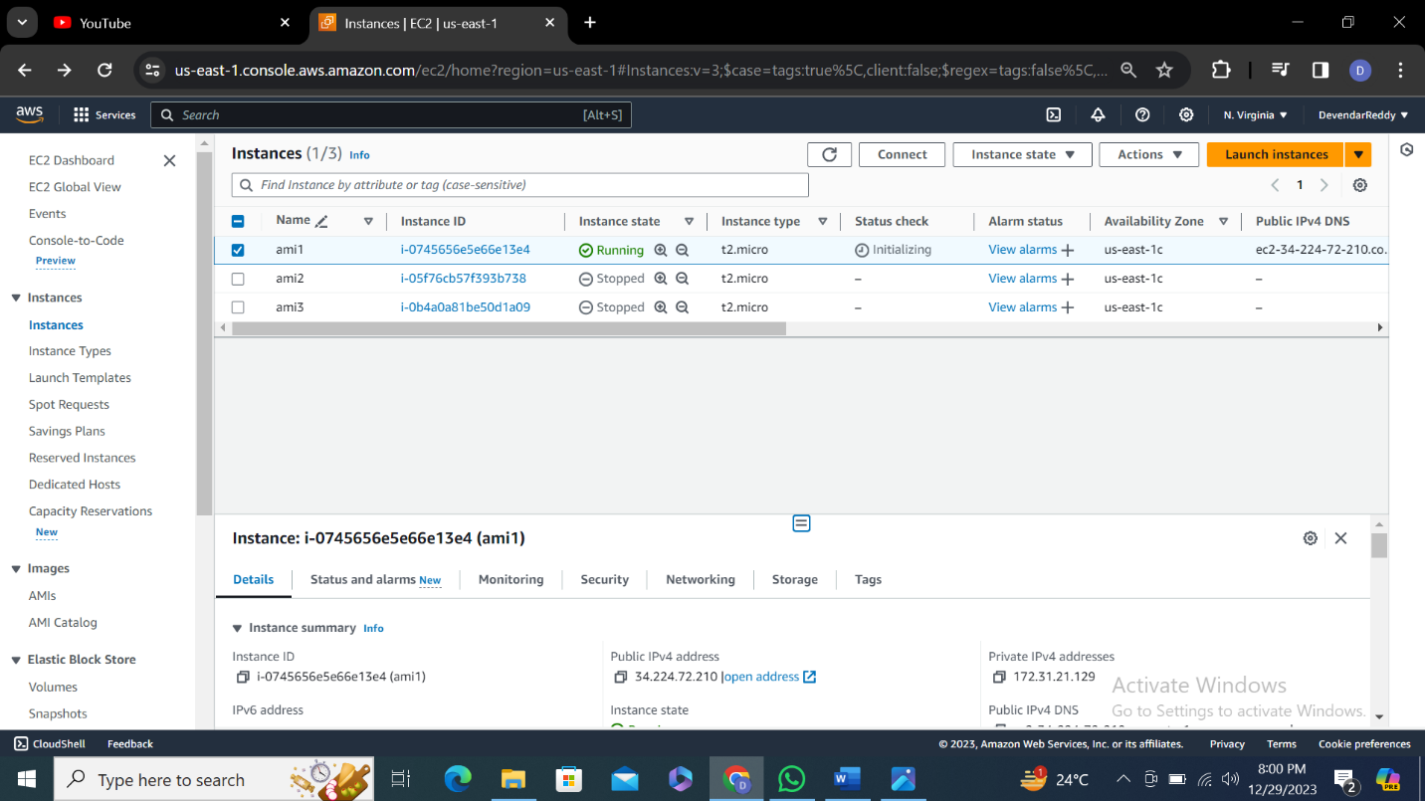

**Step-7:** Make sure username is ec2-user and click on connect.

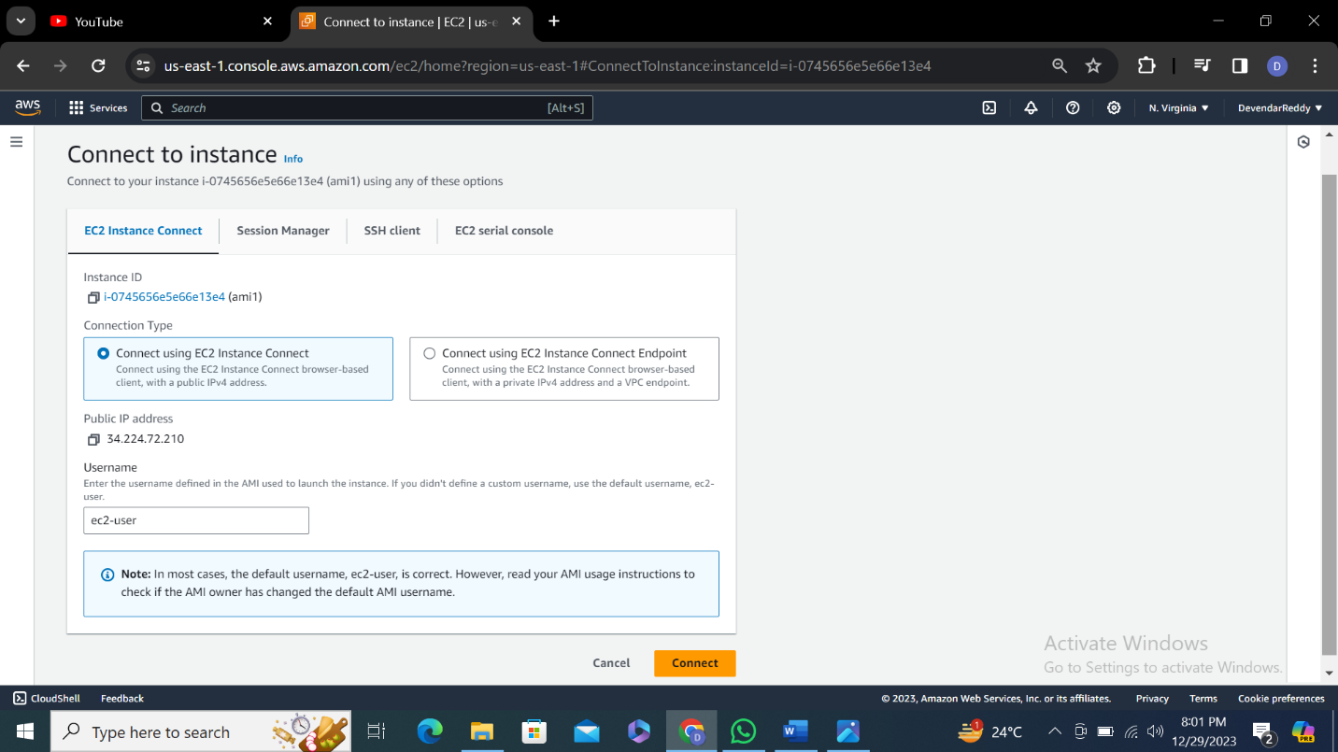

**Step-8: C**reate a file using vi cmd and write some code in it using cat cmd we can see what is written in file.

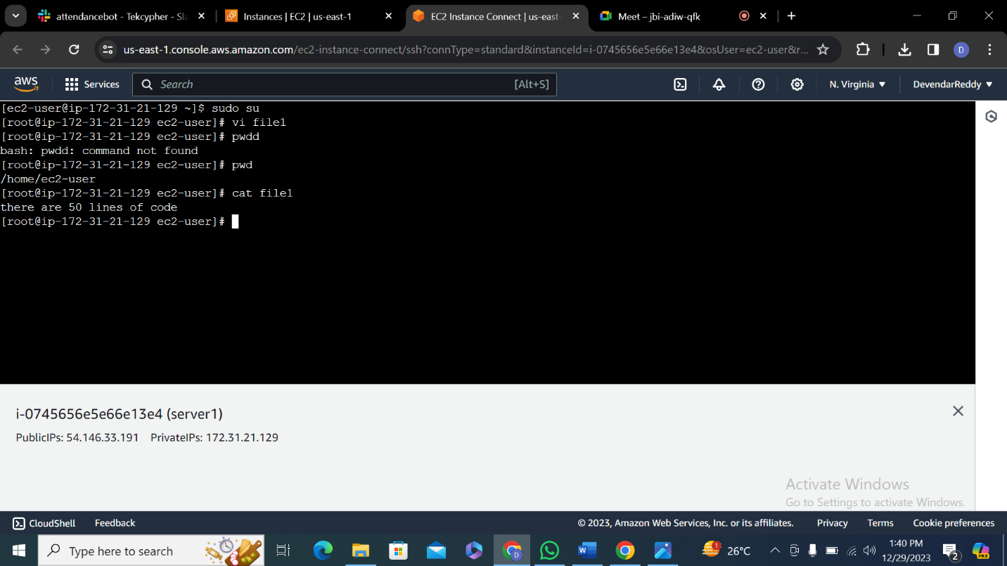

**Step-9:**

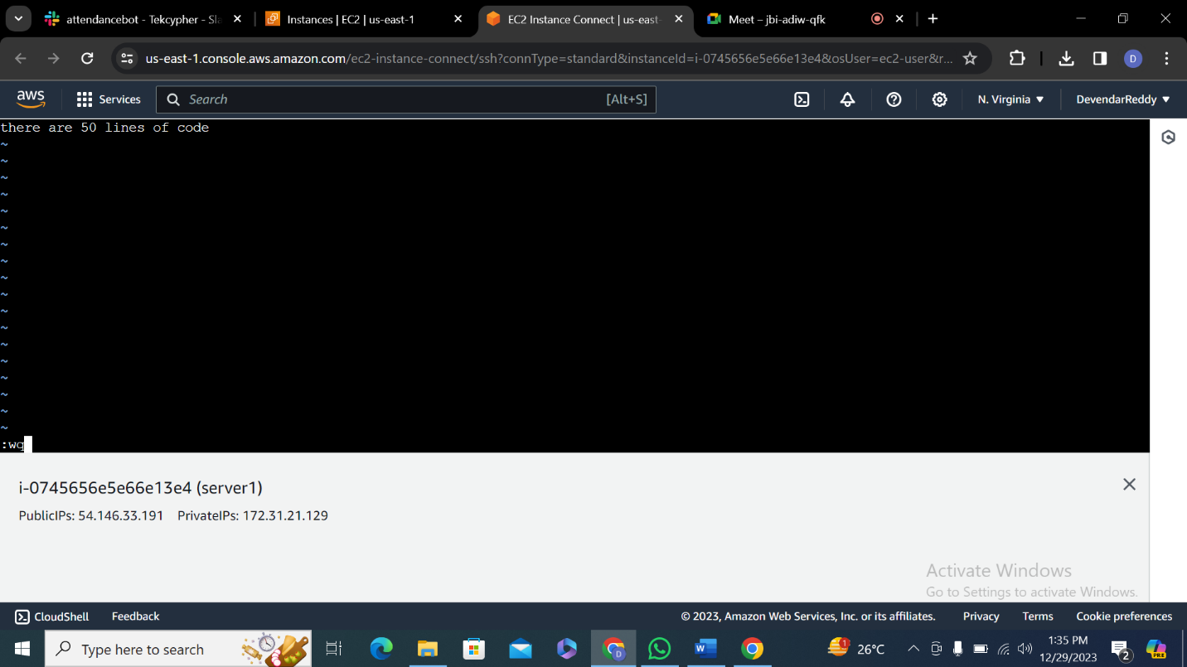

**Step-10:**  Go to amazon machine image (AMI) the ami is created click on launch instance for ami 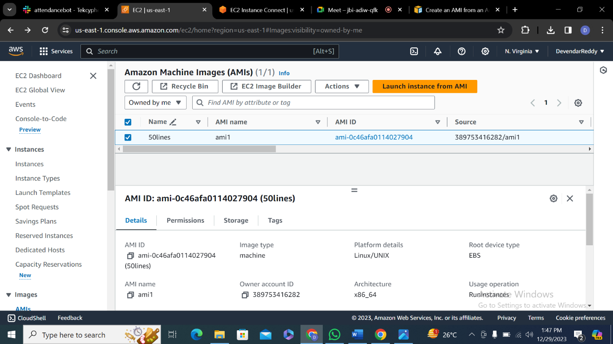

**Step-11:** Keep a name for server instance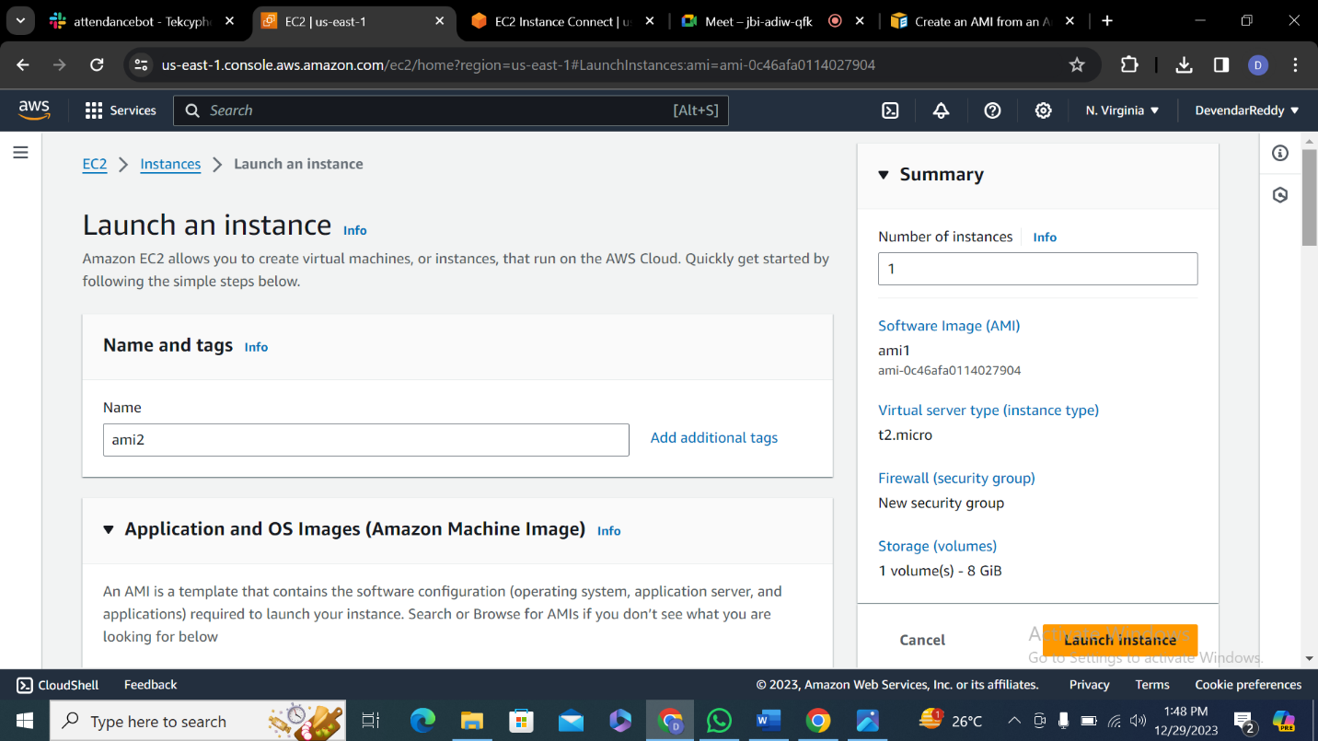

**Step-12:** Select AMI which you have previously created .

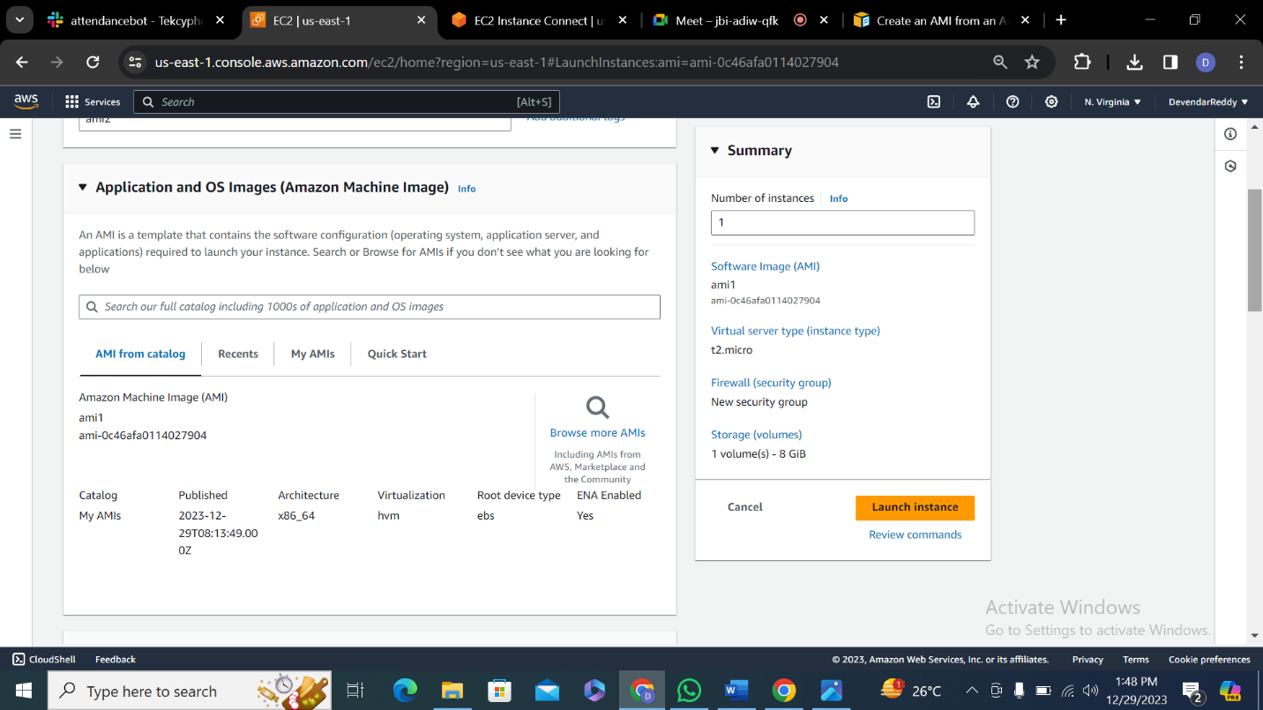

**Step-13:** Select t2 micro free tier and select a key pair for login

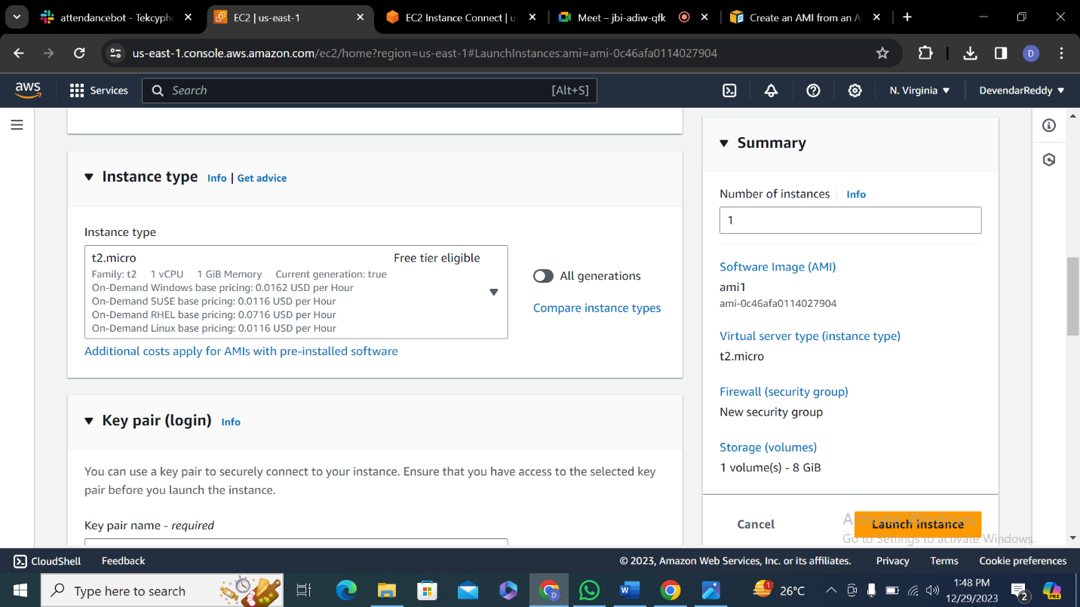

**Step-14:**

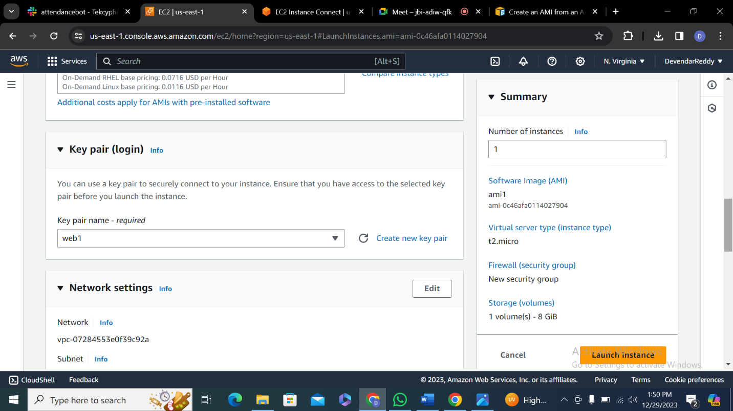

**Step-15:** Networking and configure setting are default and click on launch instance.

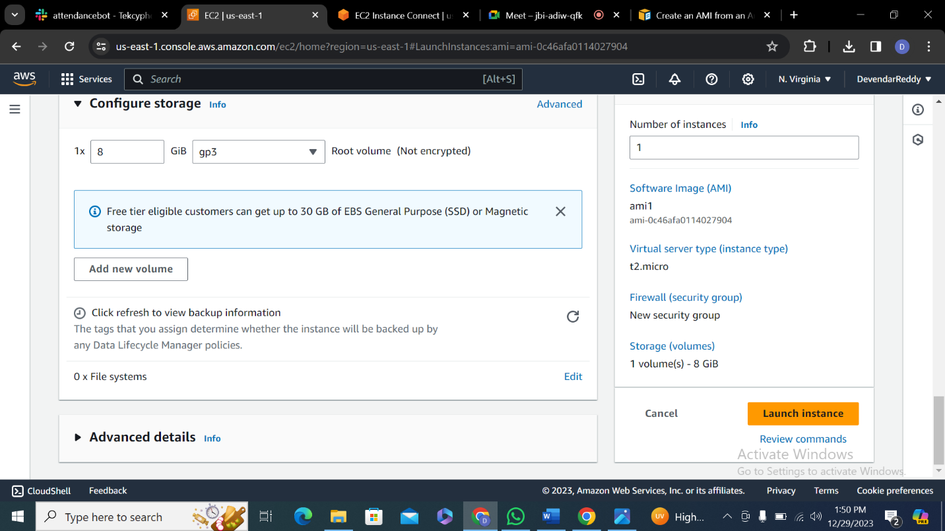**Step-16:** Click on connect and terminal will open in a web write ls cmd make sure your previously created file is there present and create new file write code in it.

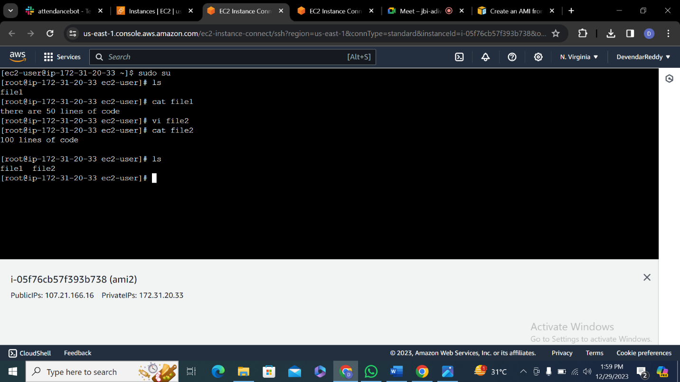**Step-17:** Click on launch instance

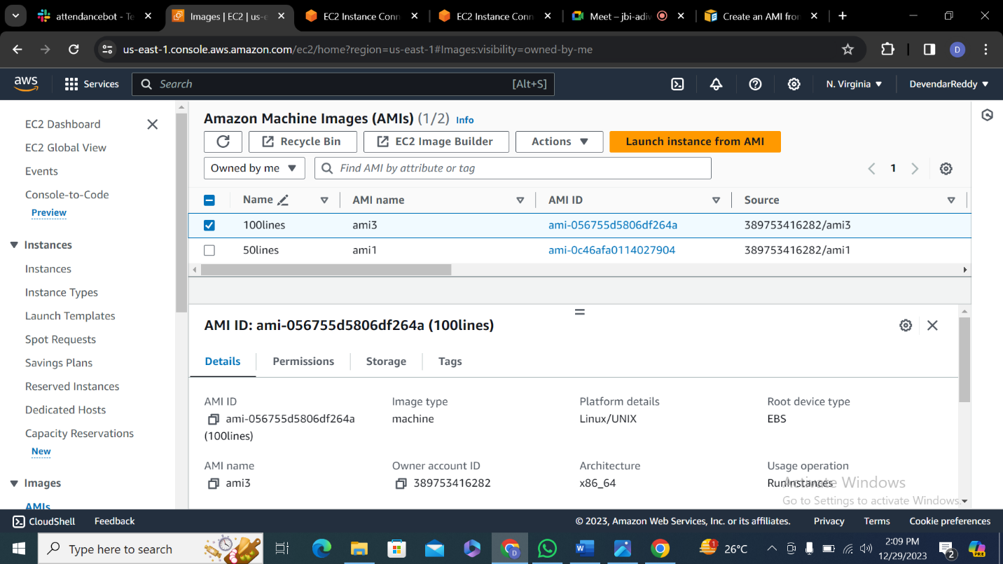

**Step-18:** Name a server

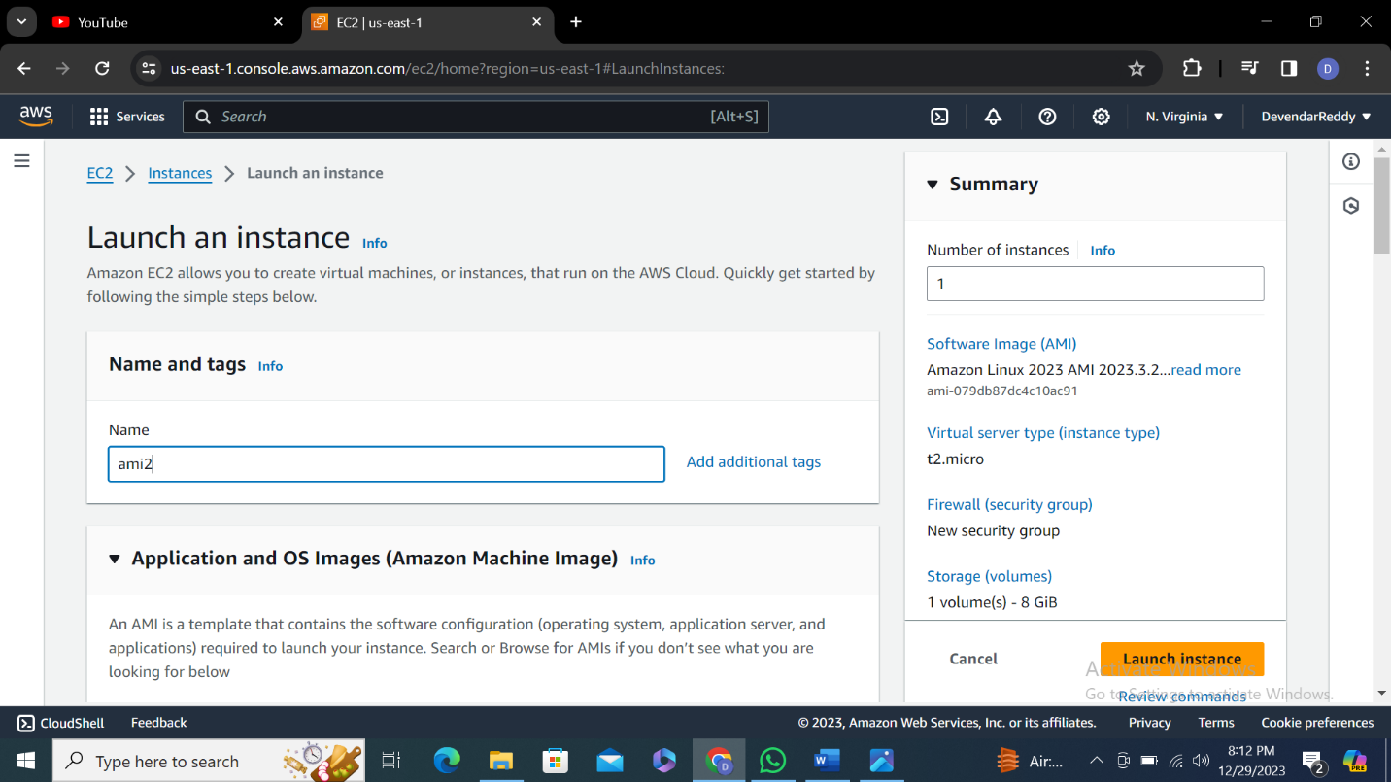

**Step-19:** Select previously created ami

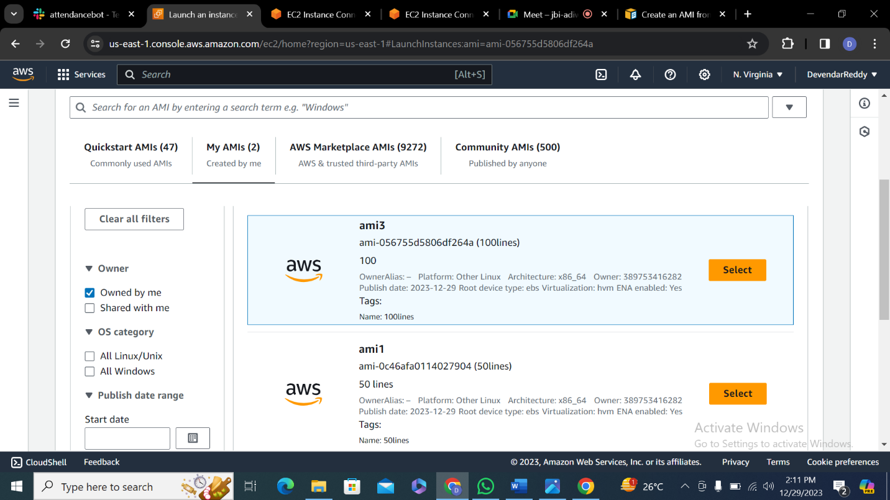

**Step-20:**  Select t2 micro free tier

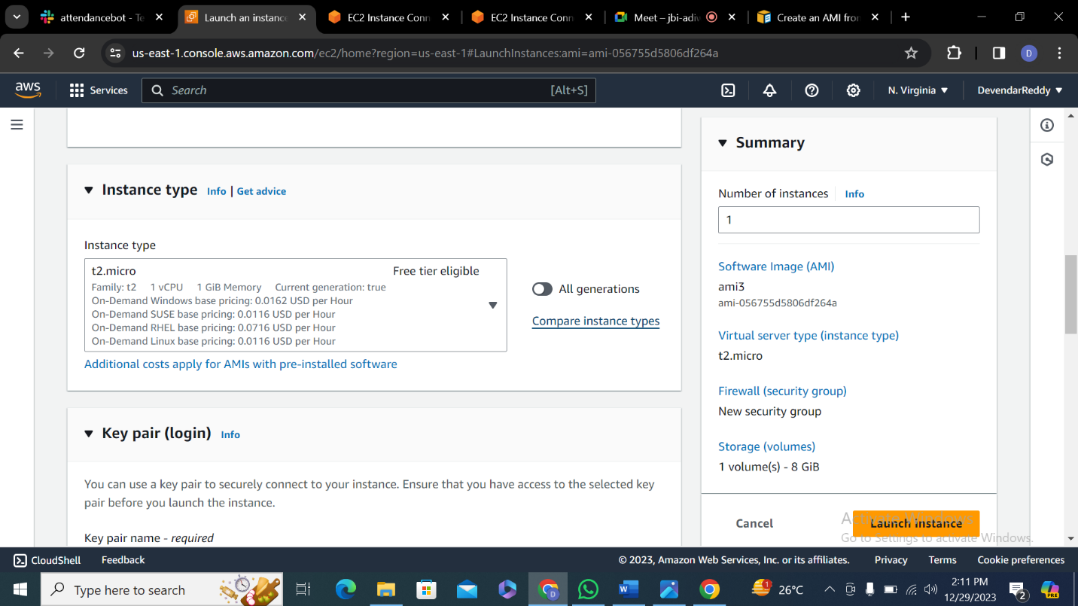

**Step-21:** Select key pair

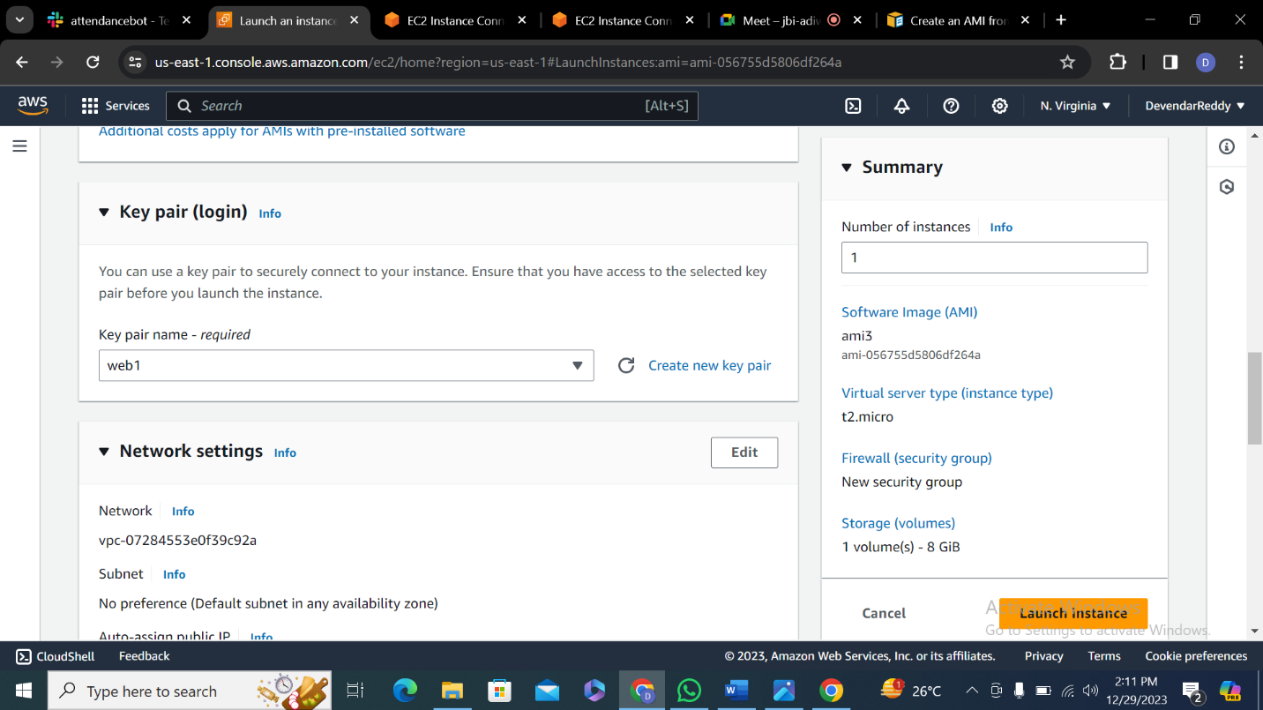

**Step-22:**  Setting are default and click on launch instance

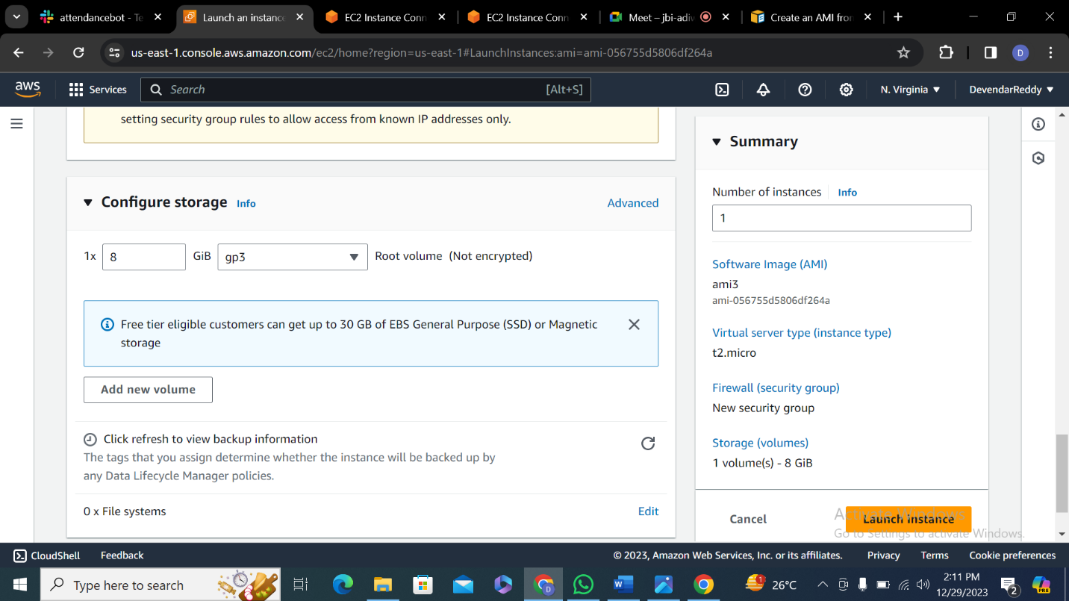

**Step-23:**  Click on connect and launch terminal will open on the web

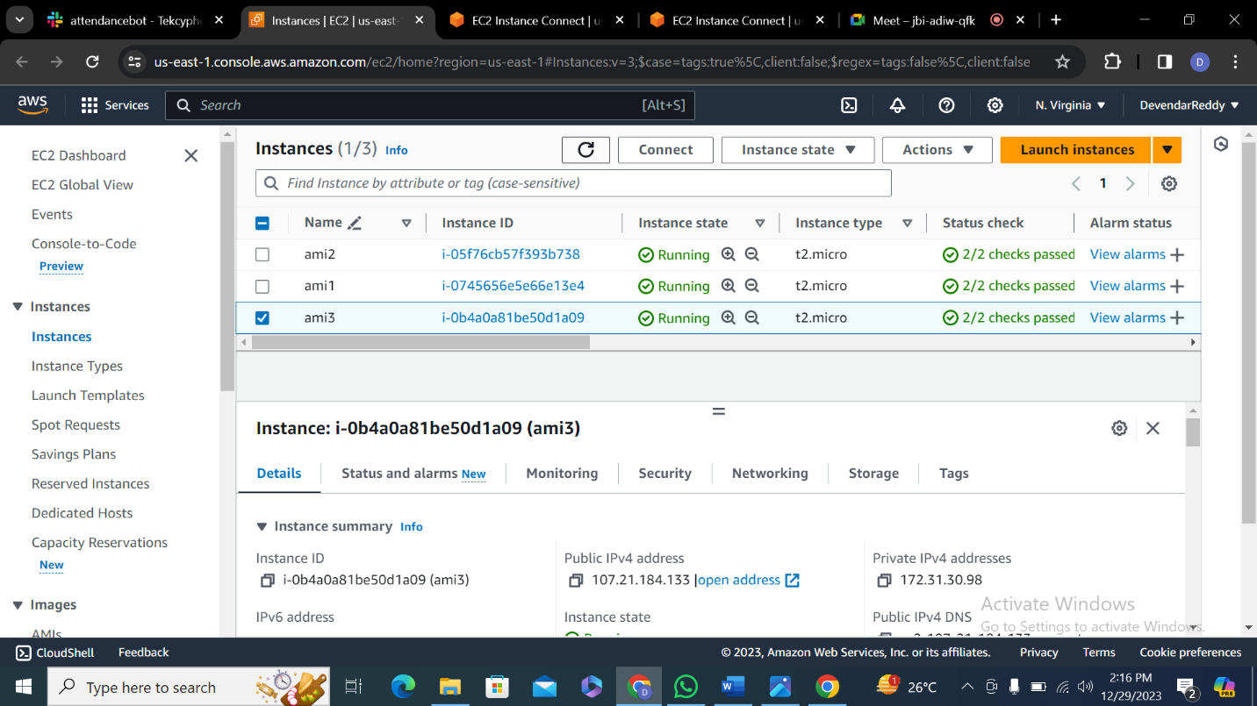

**Step-24:** Write ls cmd make sure previously created files are present and create a new file and write a code in it.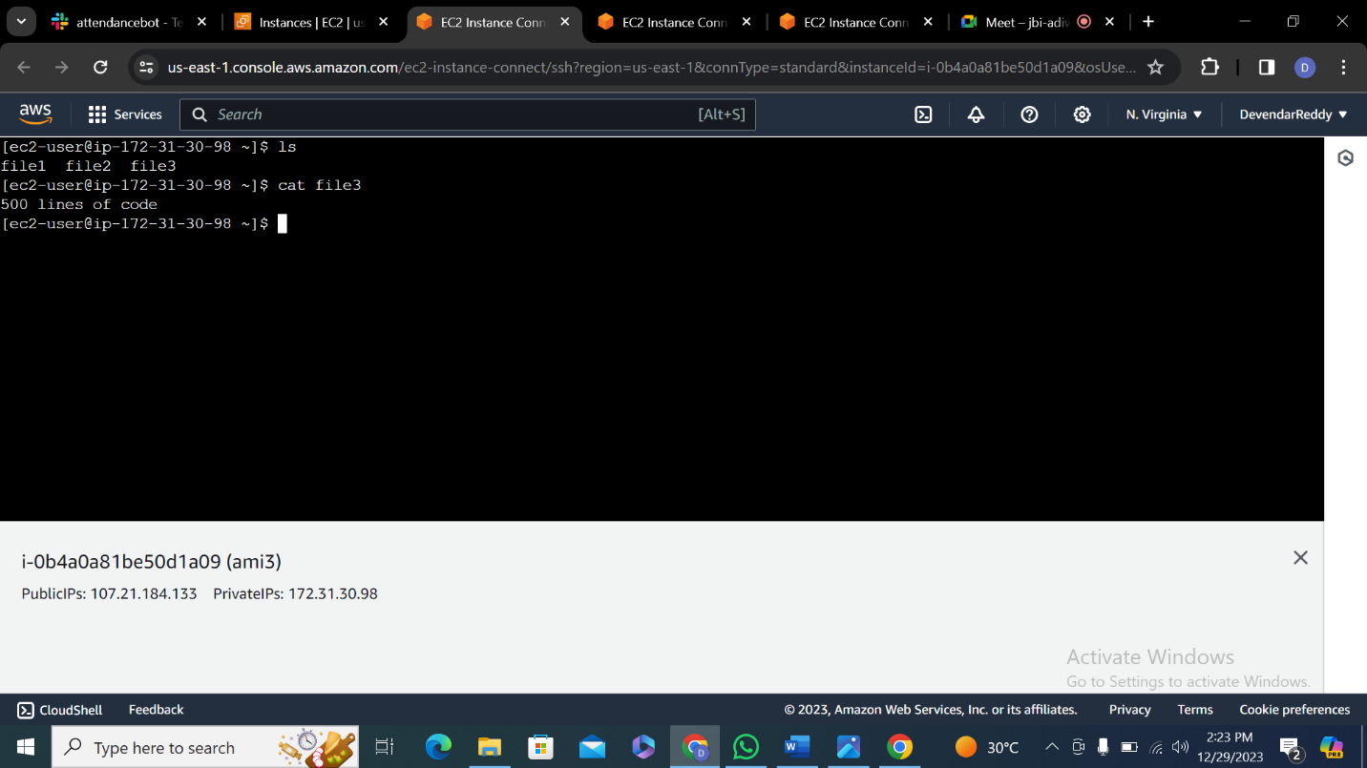

**Step-25: (3 AMIs)**

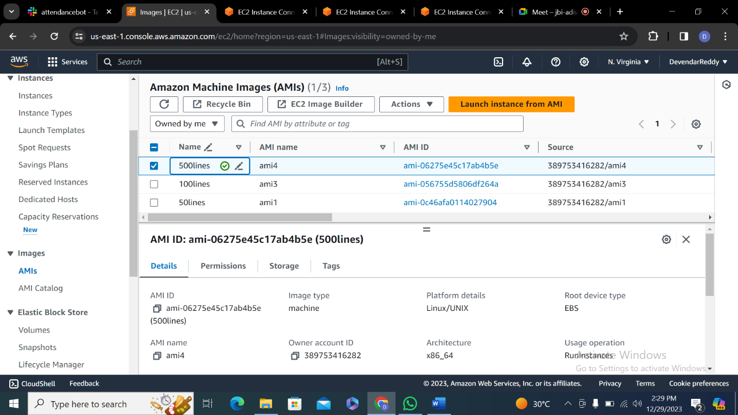

**Step-26: (3 SNAPSHOTS)**

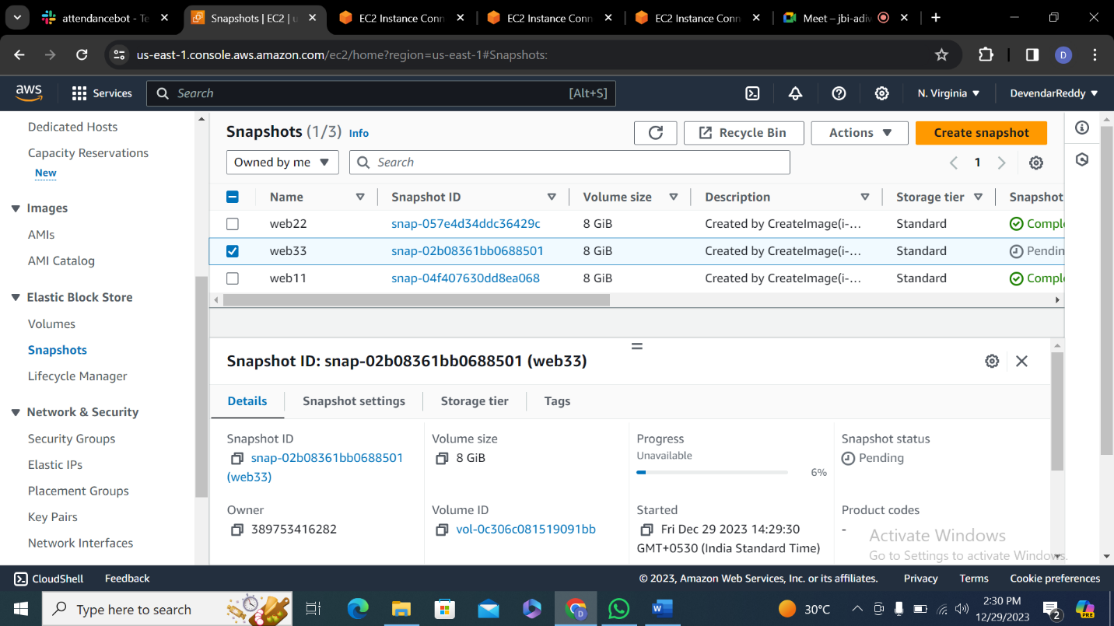

I would like send this servers from one region to another north virgina to mumbai

**Step-27:** click on action and copy ami

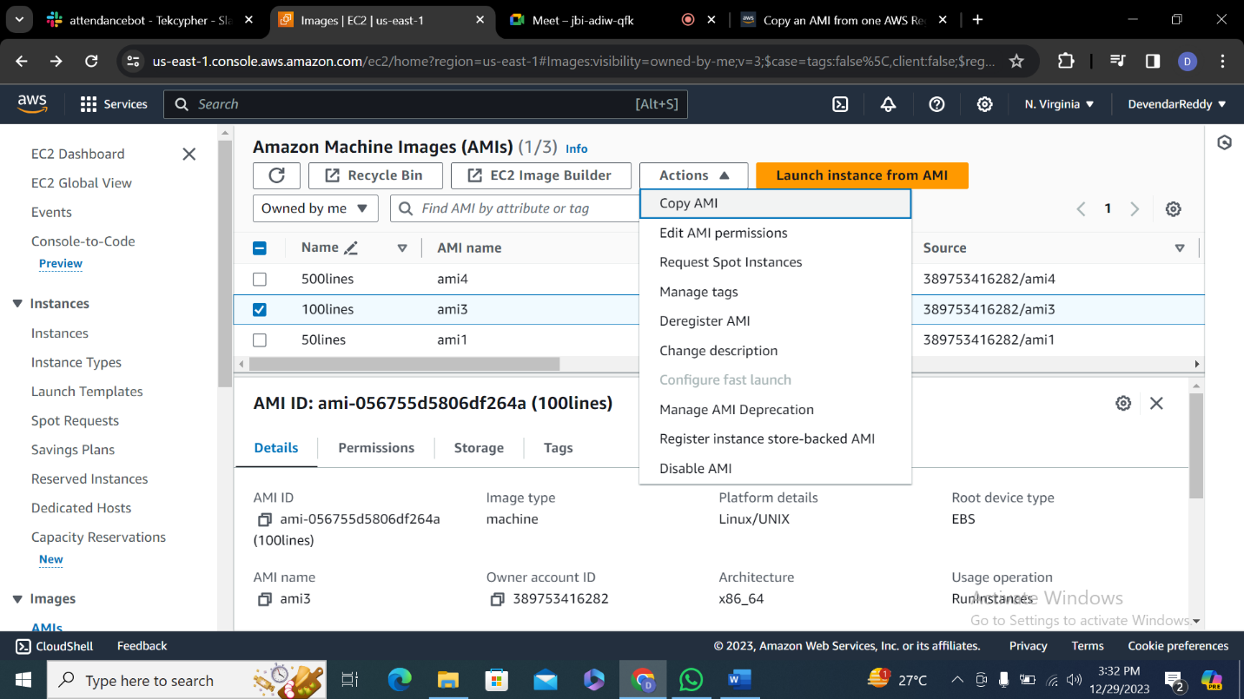

**Step-28:** Select Amidestination and click copy ami

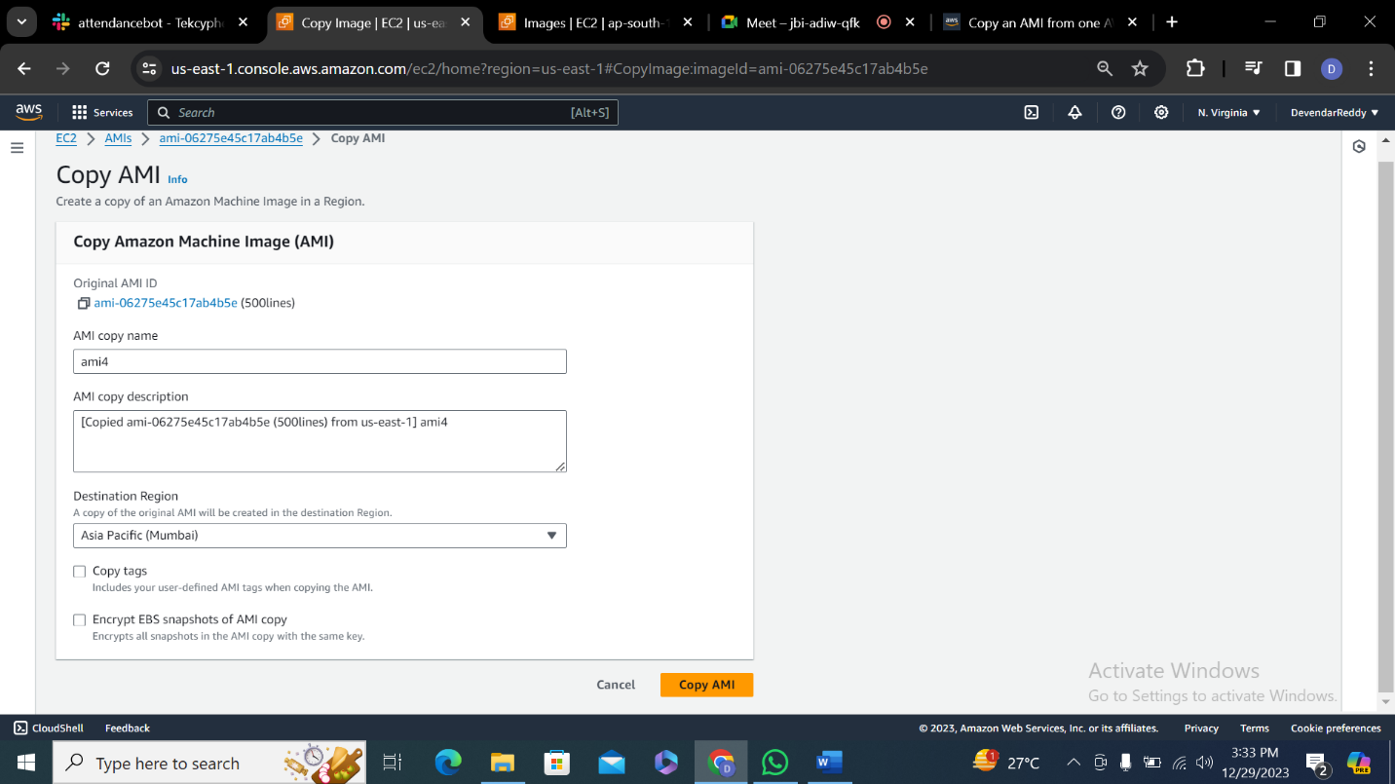

**Step-29:**

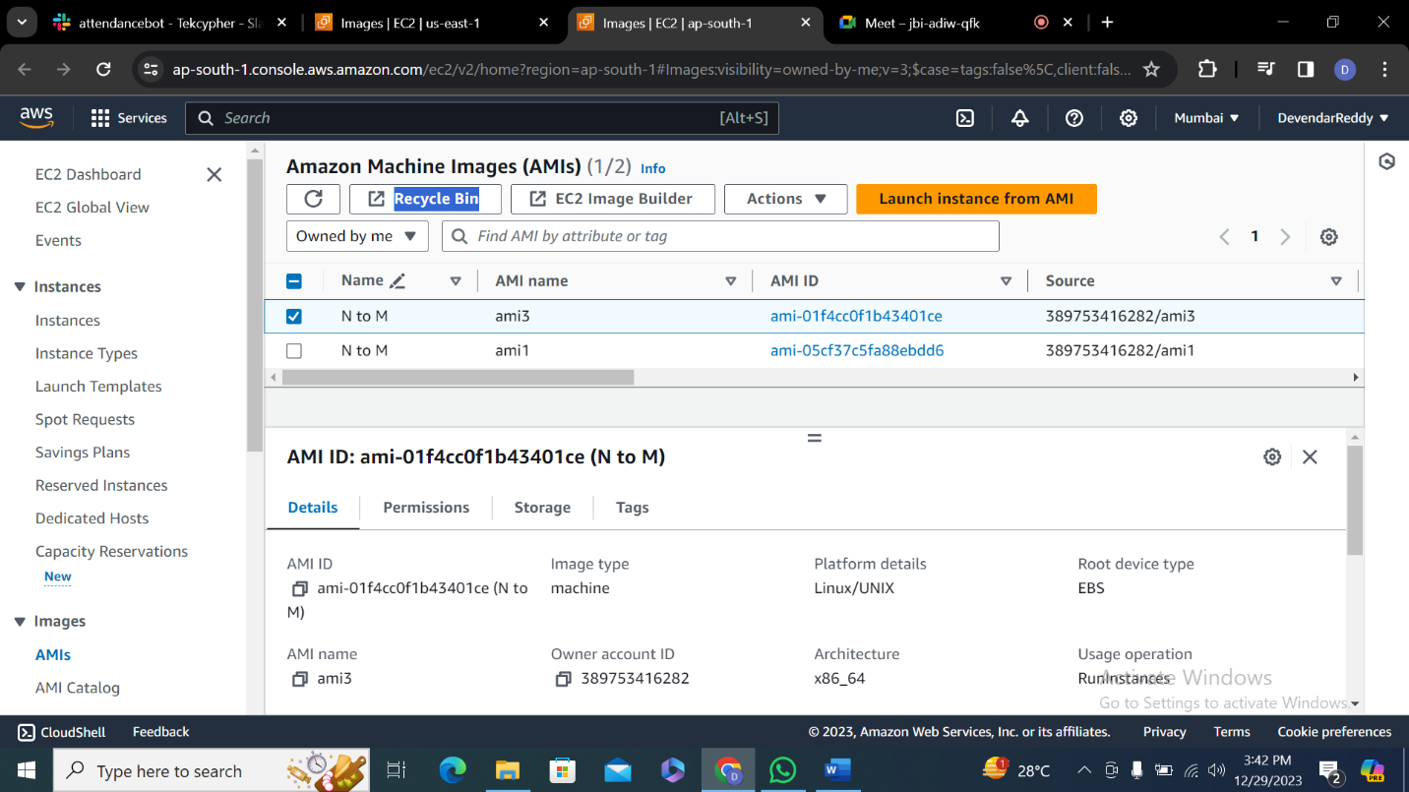

**Step-30:** Make sure status is available

